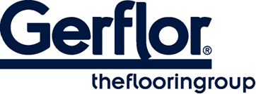
Tarasafe Ultra H₂O

TARASAFE ULTRA H₂O is a hardwearing safety flooring, with a vinyl wear layer, deeply inlaid mineral particles and coloured chips for a decorative design together with a raised emboss for better slip resistance. It is an ideal solution for traffic applications where enhanced slip resistance is required for both barefoot and shod use, such as showers, wet rooms, bathrooms, & changing areas.

The specific embossing together with the mineral particles gives a Class C barefoot slip resistance (DIN 51 097) and R11 shod slip resistance (DIN 51 130). It delivers Safety in Numbers, with a PTV> +36 slip resistance, a R11 wet slip resistance rating and >20 Rtm/Rz surface roughness in accordance with HSE guidelines.

It is reinforced with a glass fibre grid in sheet form. Its homogeneous wear layer provides a group P of abrasion.

This product is 100% recyclable and contains 39% recycled content.
It does not contain any heavy metals or CMR 1&2 and is 100% compliant
with REACH.

According to ISO 22196, it has anti-bacterial activity against MRSA of 99% after 24h00.

The product emission rate of volatile organic compounds is < 100 µg/m3 (TVOC after 28 days – ISO 16000 -6), which makes it best in class in term of indoor air quality.

